A bibliometric study on SCRUM approach: patterns, trends and GAPS

Abstract
After Agile Manifesto success on the software development arena some researches argues that SCRUM has migrated to non-software related industries/teams. This study presents a systematic literature review about SCRUM utilization, combining a blibliometric approach with content analysis. All outputs point out to the fact that SCRUM has being used by software development teams increasing customer satisfaction at the same time that reduced associated costs and development time of better managed tasks and team members. Finally, this study shows that SCRUM utilization is decreasing and/or being replaced by another project management method and it face so strong barriers to expand outside the software sector.
Keywords: Agile; SCRUM; Project Management; Bibliometric Study.

1.Introduction
Since the Agile Manifesto in 2001, several agile software development methods have come into practice, such as eXtreme Programming, Feature Driven Development and SCRUM (Vlaanderen et al., 2011).
After Takeuchi and Nonaka (1986) first publications, SCRUM has attracted the interest of software project management community have being used in widespread situations (Dingsøyr et al., 2012 and Stettina and Hörz, 2014). Agile principles are implemented at both project and organization levels so as to create the adaptive products that are easier and less expensive to change and adaptive project teams that can respond rapidly to the changes in their project’s ecosystem (Pikkarainen et al., 2008).
Rising and Janoff (2000) describe SCRUM as a development process for small teams, which includes a series of short development phases or iterations. A SCRUM team is given significant authority and responsibility for many aspects of their work, such as planning, scheduling, assigning tasks to members, and making decisions (Moe et al., 2010). The team focus is on delivering executable code and sees people as the strongest ingredient of software development (Maurer and Martel, 2002).
While agile project management is a trend in the Information Technology (IT) industry, there are also many organizations which now realize that traditional heavy-weight processes are slow, and lack interaction between customers and the product development teams (Schwaber, 2002; Salo and Abrahamsson, 2008; Dybå and Dingsøyr, 2008). Traditional process management - by continuous measurement, error identification, and process refinements— strove to drive variations out of processes, it assumes that variations are the result of errors (Highsmith and Cockburn, 2001). Thus, traditional enterprises have also become attracted by the promise of a faster time to market for their projects (Waardenburg and Vliet, 2013 and Benefield, 2008).
In this context of few studies on Scrum (Dingsøyr et al. 2012), the increasing interesting on agile project management methods (Stettina and Hörz 2014) and clear demand for more research about its utilization (Hummel 2014); this study aims to fulfill the presented gap by a systematic literature review about SCRUM utilization combining a blibliometric approach with a content analysis, performed to identify, assess and aggregate empirical evidence about the application of SCRUM as an agile method comparing its use between the software industry organizations and also non-software related ones.
The article is structured in six sections. Section 1 presents the research topic, its context and its objectives. Section 2 presents the research method and Section 3 results found. Section 4 is dedicated to discussing the findings while section 5 is devoted to conclusions and limitations.

2. Scrum overview
Takeuchi and Nonaka (1986), using the scrum rugby metaphor, having the project as the ball passed within the team as it moves as a unit up, enables real time bottleneck management while pushing the group forward. The authors presented six characteristics presented on this holistic approach: built-in instability, self-organizing project teams, overlapping development phases, multilearning, subtle control, and organizational transfer of learning.
SCRUM differs from traditional approaches in that it assumes that analysis, design and development processes are largely unpredictable (Fitzgerald et al., 2006) and group managed on daily basis. SCRUM method defines three main roles: the Product Owner, SCRUM Master and SCRUM team members. The Product Owner acts as the single ‘voice of the customer’ collecting and prioritizing customer needs onto a prioritized list of items: the product to do list, known as backlog. The SCRUM Master facilitates the SCRUM team in achieving its goal. (Vlietland and Vliet, 2015). Team members perform the tasks according to the sequence define by them on daily meetings.
During initial planning phase, the project team must develop its architecture and identify the chief architect. The chief architect defines the development project’s vision based on the architecture defined and ensures that vision’s consistency throughout all the development phases.
During the planning phase the group determines the scope of the next software release and its requirements, based on a combination of business priorities and technical estimates. And it is accepted that this plan will probably change (Fitzgerald et al., 2006). Tasks are them grouped into sprints.
Rising and Janoff (2000) describes that a sprint produces a visible, usable, deliverable product that implements one or more user interactions with the system. The key idea behind each sprint is to deliver valuable functionality. The team tracks all currently identified tasks, capturing them in a list called the backlog. The backlog drives team activity. Before each new sprint, the team updates the backlog and reprioritizes the tasks selecting the top ones to work on. Hoda et al. (2013) call attention to the fact that SCRUM is characterized by sprints work cycles, typically two to four weeks. Once a requirement has been fully specified, with the approval of a developer, the requirement can be dropped from the backlog list (Vlaanderen et al., 2011).
Important to notice that organization can make one very important decision at the end of each sprint: whether or not to continue with each product development project.

3. Research Method
This study aims to investigate the literature pattern on SCRUM and understand the key authors and publications that impact the academic community and the dissemination of SCRUM over industries outside the software development one. To achieve this objective the methodological approach is a systematic literature review, combining a blibliometric approach with a content analysis.
Pritchard (1969) define bibliometric method as to shed light on the processes of written communication and of the nature and course of development of a discipline by means of counting and analyzing the various facets of written communication. Systematic literature review differs from traditional narrative reviews by adopting a replicable, scientific and transparent process that aims to minimize bias through exhaustive literature searches of published and unpublished studies and by providing an audit trail of the reviewer’s decisions, procedures and conclusions (Cook, Mulrow and Haynes, 1997).
At the same time that bibliometric application can stimulate useful discussion among scientists and research managers about publication strategies and research directions (Moed 2002) and generate qualitative analysis through content analysis, helping to understand the key concept and research trends.
3.1 Data collection
Data collection started by searching for topics definition, i.e. by defining what would be the words or expression entered in the search engine from academic databases as search leads for finding studies related to this study objective. We first started by entering the single word “SCRUM” as Topic to be searched on the Web of Science (WoS) database, The search was further limited to only peer-reviewed articles containing the previously mentioned word, which was made by selecting only “ARTICLES” as acceptable “Document Type”. Such query retrieved 1,234 documents as search result. These documents were classified according to the number of citations, what revealed the article from Dybå and Dingsøyr (2008) and and Rising and Janoff (2000) as the most cited ones.
Based on Dybå and Dingsøyr (2008) and Rising and Janoff (2000) analysis, the string “AGILE” and “SCRUM” was introduced as searching topics. Those words together (“AGILE” AND “SCRUM”) were enough to create a broad search for all SCRUM application and at the same time limit it to the project management field of research. Queries limited “ARTICLES” on the “Document Type” field and no time limit was set for publication period.
Two repositories for research publications (WoS and SCOPUS) were selected as data source for the bibliometric study proposed. Using the same search structure presented, while WoS database contributed with 68 articles, SCOPUS presented 120. The consolidation of entries generated on the queries revealed that 48 articles were in both database leaving 140 unique records. From this initial sample, 78 articles was available for download with all metadata needed for further bibliometric analysis. Just 5 articles (~6%) were eliminated due to a misalignment of purposes with the theme of this study (see on Fig. 1).
Reading the references of the top 10 articles, we found 6 other studies that stood out, thus they were added to the existing sample, determining the final 79 articles on the research base and concluding the “Data Collection Phase”. The content analysis help to perform the in-depth qualitative analysis, identifying trend, research gaps, the core research constructs, and critical latent and manifest variable for building research framework (Duriau et al., 2007, Carvalho et al. 2015). In order to have enough understand and properly analyze the bibliometric study output we fully read 18 articles (about 22% of the sample), whose were responsible for about 60% of all citations received by the complete set (79 articles) and 100% of the other 61 articles abstracts. All steps taken in this study are presented on Fig. 1.

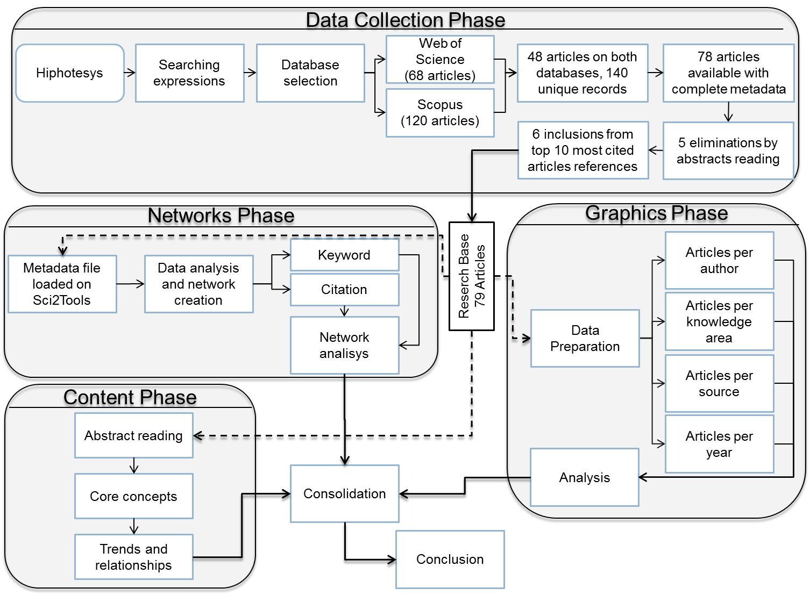
Fig. 1. Literature review workflow.

3.3 Data analysis
The bibliometric analysis present in this study starts by counting publications per journal per year. Publication counting makes it possible to identify journals that often addressed the theme and to examine the way the publications evolved over time (Carvalho et al., 2013). A citation count per journal per year was also performed, citations measure impact and influence, tracking citations and understanding their trends in context is a key to evaluating the impact and influence of researches (Using Bibliometric: A Guide to Evaluating Research Performance with Citation Data available at .http://ip-science.thomsonreuters.com/news/2008-07/8465001/ acessed on Jan 12th, 2015).
Following, four relational networks were constructed: co-citation, article citation, co-authorship and keyword. According to Qiu et al. (2014), author-level is importantly dominated at aggregation levels, because for journals, institutions and countries, every type of network is formed through authors’ academic relations such as collaboration or citation among authors. Paper citation network represents groups working with each other having thematic affinity (Carvalho et al., 2013). Co-authorship networks document scientific collaboration through published articles, where nodes are authors and a link represents the fact that two authors have written at least one article together. Co-authorship networks are thus undirected networks (Ding, 2011), representing authors working together.
The analysis follows by studying publication by research area. Such analysis may reveal how spread the research main topic “SCRUM” is among different research area, what may be a proxy for how spread it is among different utilization fields. In other words, it may shed light to the fact that “SCRUM” could be used not only by software related project management but also by non IT related ventures.
During network creation and analyzes we used the centrality indicator measurement, where the centrality of a node X is defined as the sum of the centralities of the nodes with edges pointing to X, divided by a constant. The displayed size of a node represents its centrality (Ziegler, 2009). Freeman (1978) formalized three different measures of node centrality: degree, closeness, and betweenness, measures generalized to weighted networks. Opsahl et al. (2010) explain the measurements defining degree as the number of nodes that a focal node is connected to, measuring the involvement of the node in the network, closeness as being in a position to reach others quickly and betweenness assess the degree to which a node lies on the shortest path between two other nodes, able to funnel the flow in the network.

4. Results
Since there was no time limit set for publication period, all articles matching the other query criteria were included on the search results. Table 1 presents the number of articles published per journal per year. Considering the sample collected, the oldest article published is in 2002, the work of Rising and Janoff (2000): “The SCRUM software development process for small teams”.
In the 14-year period starting in 2000, 79 articles were published. In 2012, the most prolific year on the series, 16 studies were published. Publication volume does not show a steady progression it actually presents variations in a way that 2013, the year following the publication peak, only 7 articles were published, less than 50% of the previous year. From 2000 until 2009 (both inclusive) the annual average number of published is 2.5 articles per year. In 2009 2 articles were published and in 2010 this number jumps to 10 a 5 folds increase. About the number of citation presented, a fact to be noted is that there is no concentration of articles cited in a few sources/journals. Revealing that there is not a SCRUM niche journal and knowledge has being disseminated by several publications.

Table 1. Number of publications per journal and per year
Source | 2000 | 2001 | 2002 | 2003 | 2004 | 2005 | 2006 | 2007 | 2008 | 2009 | 2010 | 2011 | 2012 | 2013 | 2014 | Total
JOURNAL OF SYSTEMS AND SOFTWARE |  |  |  |  |  |  |  |  |  |  | 2 |  | 7 | 2 |  | 11
INFORMATION AND SOFTWARE TECHNOLOGY |  |  |  |  |  |  |  |  | 1 |  | 1 | 1 | 1 | 2 | 4 | 10
IEEE SOFTWARE | 1 |  |  |  |  | 1 |  |  |  | 1 | 1 | 1 | 1 |  | 1 | 7
EXTREME PROGRAMMING AND AGILE PROCESSES IN SOFTWARE ENGINEERING, PROCEEDINGS |  |  |  |  |  | 2 | 3 |  |  |  |  |  |  |  |  | 5
JOURNAL OF SOFTWARE-EVOLUTION AND PROCESS |  |  |  |  |  |  |  |  |  |  |  |  | 1 | 1 | 1 | 3
EMPIRICAL SOFTWARE ENGINEERING |  |  |  |  |  |  |  |  | 1 |  | 1 |  |  |  | 1 | 3
SOFTWARE-PRACTICE & EXPERIENCE |  |  |  |  |  |  |  |  |  |  |  | 3 |  |  |  | 3
EXTREME PROGRAMMING AND AGILE METHODS - XP/ AGILE UNIVERSE 2004, PROCEEDINGS |  |  |  |  | 3 |  |  |  |  |  |  |  |  |  |  | 3
ELEKTRONIKA IR ELEKTROTECHNIKA |  |  |  |  |  |  |  |  |  |  |  | 1 | 1 |  |  | 2
JOURNAL OF SOFTWARE MAINTENANCE AND EVOLUTION-RESEARCH AND PRACTICE |  |  |  |  |  |  |  |  |  |  | 1 | 1 |  |  |  | 2
IEEE TRANSACTIONS ON EDUCATION |  |  |  |  |  |  |  |  |  |  |  | 1 | 1 |  |  | 2
IET SOFTWARE |  |  |  |  |  |  |  |  | 1 |  |  |  | 1 |  |  | 2
Other journals with ony 1 publication |  | 1 | 1 | 2 | 1 | 1 | 3 | 1 | 0 | 1 | 4 | 1 | 3 | 2 | 4 | 26
Total | 1 | 1 | 1 | 2 | 4 | 4 | 6 | 1 | 3 | 2 | 10 | 9 | 16 | 7 | 11 | 79
Journals are listed in descending order of articles published

The annual total citation count evolution is presented on Fig. 2, it shows very few citations before 2008, more precisely, 67 since 2000. In 2008 Dybå and Dingsøyr (2008) published the most cited article on the sample with 212 citations until 2015, contributing to a noticeable increase on the number of citations and their dominance on the top cited article. The authors make a literature review investigating what was currently known about the benefits and limitations of, and the strength of evidence for, agile methods. Authors cover several agile methods like Crystal, Dynamic Software Development Program, Lean Software Development and SCRUM. Always having in mind that software development should be organized in order to deliver faster, better, and cheaper solutions.
As it happens in the number of publications per year, there is not a growth pattern on citation volume. After reaching the citation peak in 2013 with 197 citations, citation volume dropped to 131 in 2014. Analyzing the citation evolution while some may claim that agile software development methods are in the mainstream adoption phase in the software industry, others hope that those are a passing fad. Laanti et al. (2011).
Fig. 3 presents the citations evolving changes of the top ten most cited articles. The articles Rising and Janoff (2000) and Highsmith and Cockburn (2001) had their citation volume reduced and also lost participation on total citation, mainly from 2002 to 2009, when newer articles started to be cited. It also shows that Dybå and Dingsøyr (2008), published in a more prestigious publication rapidly increased its participation on total citation reaching the top of most cited articles rank.

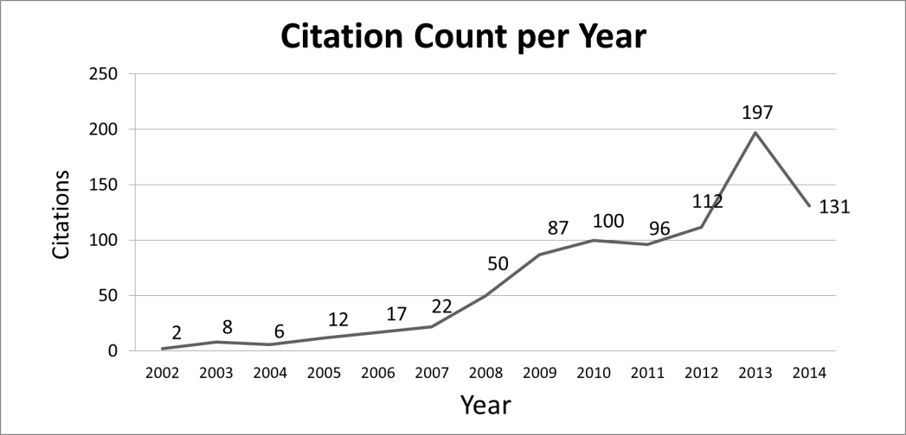
Fig. 2. Citations count evolution over time

Fig. 3. Evolving changes of citations of the tem most-cited articles

As expected as the number of authors studying a determined topic increases more articles became available and the participation of each on the total citation tends to reduce. What may be different about SCRUM is the dominance of Dybå and Dingsøyr (2008) as the most cited article for the last five straight years, as shown on Table 2.

Table 2: 2010- 2014 three most cited articles
Year | Most Cited | 2nd. Most cited | 3rd. Most cited
2014 | Dybå and Dingsoyr (2008) | Highsmith and Cockburn (2001) | Moe et al. (2010)  Dingsoyr et al. (2012)
2013 | Dybå and Dingsoyr (2008) | Fitzgerald et al. (2006) | Dingsoyr et al. (2012)
2012 | Dybå and Dingsoyr (2008) | Highsmith and Cockburn (2001)  Pikkarainen et al. (2008) | Rising and Janoff (2000)  Moe et al. (2010)
2011 | Dybå and Dingsoyr (2008) | Highsmith and Cockburn (2001) | Rising and Janoff (2000)
2010 | Dybå and Dingsoyr (2008) | Highsmith and Cockburn (2001)  Rising and Janoff (2000) | Fitzgerald et al. (2006)

The core articles (see Fig. 3 and Table 3), considering the number of citation as a Proxy of impact in the academic community, are in depth discussed in terms of the knowledge contribution for new generation of studies.
Dybå and Dingsøyr (2008) present a very detailed review not only about agile methods but also on specific methods: XP, SCRUM, Crystal, DSDM, FDD, and Lean. The broader review made by the author gave it latitude to be cited by several others focusing on deeper view on one segment presented. Authors presented on the top 10 citation rank make it clear that their study to be directed towards software development, as it is expressed on the keywords selected: Empirical software engineering; Evidence-based software engineering; Systematic review; Research synthesis; Agile software development; XP; Extreme programming; SCRUM. Highsmith and Cockburn (2001) understand that agile methods view change from a perspective that it mirrors today’s turbulent business and technology environment helping development team in copying with this uncertainty. The two main topics covered by Dybå and Dingsøyr (2008) and Highsmith and Cockburn (2001), respectively “agile methods” and “teams” i.e. software development team’s characteristics when agile methods are deployed, are very close related to the topics covered by other authors in the sample.
According to the research area classification provided by the WoS and pictorially represented on Fig. 4, 71 out of the 79 articles on the sample are classified as belonging to the Computer Engineering area, reinforcing the fact that the vast majority of studies are related to software development.

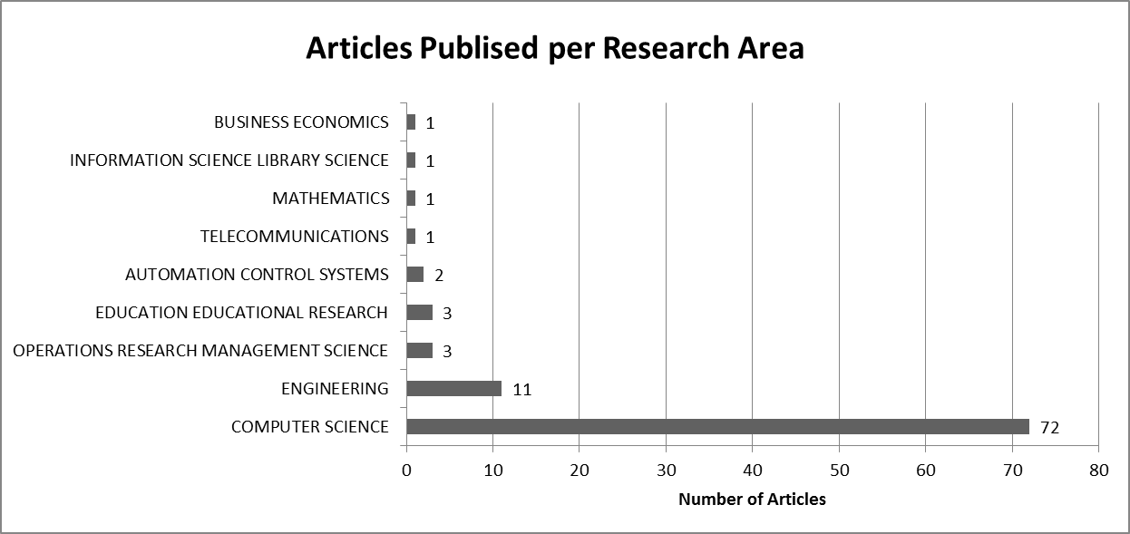
Fig. 4. Articles published by research área

5.Discussões
Relationship networks can also be used as a toll for bibliometric analysis. The first network we constructed is the article citation one. According to Garfield, (2001) co-citation analysis is based primarily on identifying pairs of highly-cited articles, co-citation is essentially a forward-looking perspective, prove to be accurate markers for the emergence of new topics. Fig. 5 below presents the co- citation network which is constructed with the original sample of 79 articles along with all articles mentioned on the reference list. The full network formed is composed by 2,325 studies.

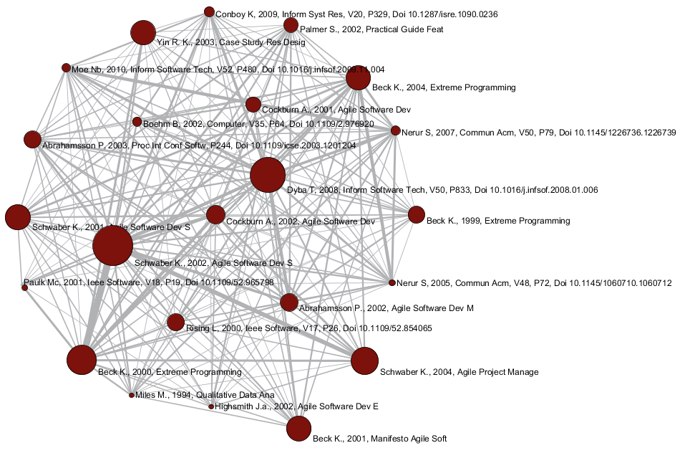
Fig. 5. Co-citation network for top 10% of article by citation after 42 isolated nodes removal
The generated pool of cited article was trimmed for the 10% most cited works, associated with the 23 nodes generated, following the criteria used in (Carvalho et al., 2013). The size of the circles representing the articles are proportional to the number of citations they received and the thickness of the arrow connecting to articles correlates with the number of times the authors of connected articles cited each other. The co-citation network reveals that even though Dybå and Dingsøyr (2008) was the most cited on the original sample of 79, Schwaber and Beedle (2002) is the one more frequently cited on those articles related to “AGILE” and “SCRUM”. Schwaber and Beedle (2002) refers to the book “Software Development with Scrum” cited, according to Google citation count 2.390 times. Articles from the same author, about Agile Software Development and Management are also highly cited.
Besides that, one can notice that 3 of the original 79 article made cut of the 10% most cited (Dybå, 2008; Rising, 2000; Moe et al., 2010). Those are articles with broader coverage of the agile theme, what may explain the citation volume received.
Considering the network centrality analysis output generated by Sci2Toll, presented on Table 4, Nerur and Balijepally. (2007) appears as the most central study followed by Miles and Huberman (1994) and Highsmith (2002). The best ranked article from the original sample is Dybå and Dingsøyr (2008) in 6th place. Finally, on Table 3, reading the article´s name, it is possible to notice that only 1 work is related scrum and no one have any lead to the scrum application outside the software industry.
The co-authorship network presented on Fig. 6 reveals that considering the top 20 most cited articles, there is co-authorship relationships between well-defined groups, and some groups do have the behavior of cross-citing its members. Fig. 7 presents the article citation network for the 79 articles on the original sample, the local citation count. From the network it is possible do visualize that cluster of author do exist and that there is few connection among groups of works.
Finally, the keyword network considering the top 20 keywords by citation count shows that even though the word SCRUM has being cited by many articles, as the size of the circle reveals, its strongest connections are with software development and agile methods word. In the keyword network the SCRUM word having no connection with any word that could represent its utilization outside the software development calls attention (see Fig. 8). Besides, keyword related to software developments are present: Software Process Improvement, Extreme Programming and Release Planning, for example.

Table 4. Co-citation network betweenness_centrality
Author | Title | Local  citation | On original set of 79
Nerur and Balijepally. (2007) | Theoretical reflections on agile development methodologies | 8 | *
Miles and Huberman (1994). | Qualitative data analysis: An expanded sourcebook | 6 | *
Highsmith (2002) | Agile software development ecosystems. | 6 | *
Paulk (2001) | Extreme programming from a CMM perspective | 6 | *
Schwaber and Beedle (2002) | Agile Software Development with Scrum | 24 | *
Dybå and Dingsøyr (2008) | Empirical studies of agile software development: a systematic review | 17 | Yes
Beck (2000) | Extreme Programming Explained: Embrace Change | 19 | *
Schwaber (2004) | Agile Project Management with Scrum | 16 | *
Schwaber and Beedle (2001) | Agile Software Development with Scrum | 11 | *
Beck et al. (2001) | Agile manifesto | 10 | *
Beck ( 2004) | Extreme Programming Explained: Embrace Change (2nd edition) | 14 | *
Yin (2003) | Case Study Research: Design and Methods | 7 | *
Cockburn (2002) | Agile software development joins the ‘would-be’ crowd” | 10 | *
Abrahamsson et al. (2002) | Agile software development methods: Review and Analysis. | 10 | *
Abrahamsson (2003) | Extreme programming: first results from a controlled case study | 9 | *
Rising and Janoff (2000) | The Scrum software development process for small teams | 8 | Yes
Beck (1999) | Embrace change with extreme programming | 7 | *
Cockburn and Highsmith (2001) | Agile software development: The people factor | 7 | *
Palmer S., 2002 | A practical guide to feature-driven development | 8 | *
Conboy (2009) | Agility from first principles: reconstructing the concept of agility in information systems development | 7 | *
Boehm (2002) | Get ready for agile methods, with care | 7 | *
Moe et al. (2010) | A teamwork model for understanding an agile team: A case study of a Scrum project | 7 | Yes
Nerur et al. (2005) | Challenges of migrating to agile methodologies | 7 | *

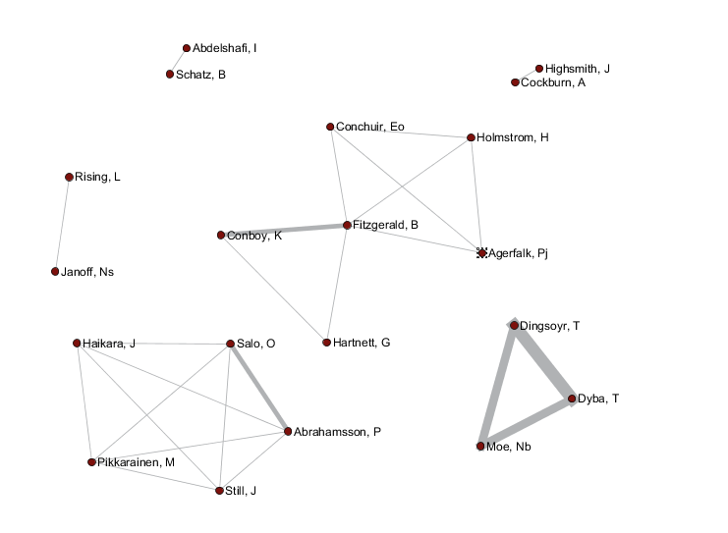
Fig. 6. Co-authorship network – Top 20 by citation

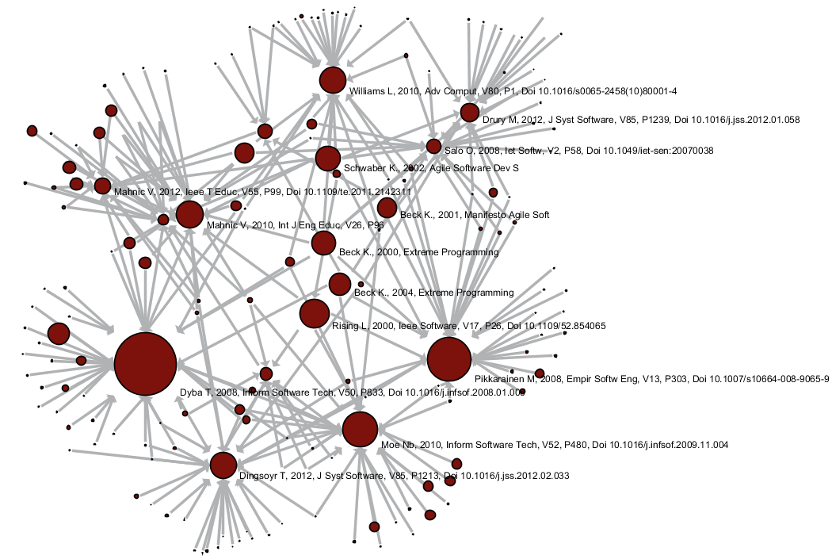
Fig. 7. Article citation network with centrality for local citation count greater than zero without isolated nodes

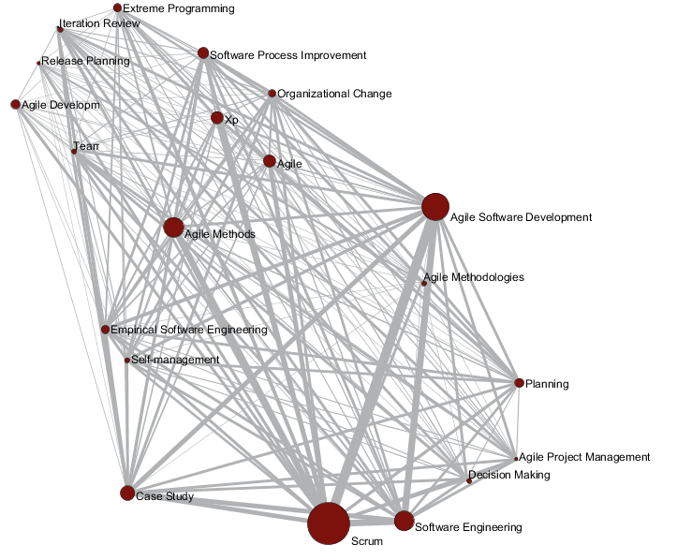
Fig. 8. Keyword network top 20 by occurrence
6. Conclusões
From the bibliometric analysis and content analysis presented the publications pattern of SCRUM literature can be delineated.
Data presented suggest an opposite direction in relation do SCRUM adoption, based on the behavior of the volume curve of publications and citations, along with the research areas covered one may say that SCRUM could actually be a fad on project management as perception pointed out by Laanti et al. (2011).
Co-authorship analysis revealed that closed cluster of authors do exist and those cluster all reside in the software engineering research area, pointing out that SCRUM may be studied and adopted by the software community. Moreover, if SCRUM has been expanded to other industries and fields, more connections between groups of authors would exist, and different research areas would be found. The keyword analysis also corroborates that interesting on SCRUM remains releted to on software topics once the two main topics researched are: software development teamwork and SCRUM implementation, .
Thus, assertions like “in the last ten years the use of agile methods has become widespread (Dingsøyr et al., 2012) or “agile project management methods are gaining increased attention in the general field of project management (Stettina and Hörz, 2014) or “press releases, scientific publications and anecdotal evidence demonstrate that organizations worldwide are adopting agile software development methods at increasing speed” (Salo and Abrahamsson, 2008), they are all right, but in the software development industries, considering the SCRUM approach.
This study presents clear limitations related to research method adopted. Bibliometric analysis reflect the biases of the databases used and because of the focus on Thomson Scientific’s databases, it can be said to by-and-large reflect the limits of Thomson Scientific’s databases. (Archambault et al., 2006).
Even though ISI Web of Science database is indexed and articles were published in credited journals with calculated and normalized impact factor, by Journal Citation Report, it would be fair to assume that there may have other relevant articles not considered in this study. We mitigate this limitation by searching in Scopus database. The search strings also represent limitations, since articles like Takeuchi and Nonaka (1986) that is in the surveyed databases did not appear in the search processes, despite its 266 citation. Other limitation is on the use of citation counts as the main driver for the bibliometric analysis, which assumes that most frequent cited articles are more relevant for knowledge creation than other with lower citation counts. In order to overcome those limitations, futures studies could include a large number of database as source of articles or apply other methodologies such as the literature review and explore other search strings.
Finally, this study shows the opportunity for future researches to investigate whether SCRUM utilization is decreasing and/or being replaced by another agile method and why it face so strong barriers to expand outside the software sector. Besides, there is an opportunity for verifying how those agile methods applied to software development interact with other projects managed by Project Management Offices.

Referências
Abrahamsson, P.. Extreme programming: first results from a controlled case study. Euromicro Conference, 2003. Proceedings. 29th(pp. 259-266). IEEE.

Abrahamsson P.; Salo O.; Ronkainen J.; Warsta J.; “Agile software development methods”, VTT Publications 478 (2002).

Archambault, E.; Vignola-Gagne, E.; Cote, G.; Lariviere, V.; Gingras,Y. (2006). Benchmarking scientific output in the social sciences and humanities: The limits of existing databases. Scientometrics, 68(3), 329–342.

Carvalho, M.M. Fleury, A.L.; & Lopes, A.P. (2013), An overview of the literature on technology roadmapping (TRM): Contributions and trends. Technological Forecasting & Social Change, 80 (7) 1418–1437.

Cook, D. J.; Mulrow, C. D.; Haynes, R. B. (1997). Systematic reviews: synthesis of best evidence for clinical decisions. Annals of internal medicine,126(5), 376-380.

Dingsøyr, T.; Hanssen, G. K.; Dybå, T.; Anker, G.; Nygaard, J. O. (2006). Developing software with scrum in a small cross-organizational project. Software Process Improvement (pp. 5-15). Springer Berlin Heidelberg.

Dingsøyr, T.; Nerur, S.; Balijepally, V.; Moe, N. B. (2012). A decade of agile methodologies: Towards explaining agile software development. Journal of Systems and Software, 85(6), 1213-1221.

Duriau, V.J. Reger, R.K.; Pfarrer. M.D. (2007), A content analysis of the content analysis literature in organization studies research themes, data sources, and methodological refinements. Organ. Res. Methods, 10 (1) pp. 5–34

Dybå, T.; Dingsøyr, T. (2008). Empirical studies of agile software development: A systematic review. Information and software technology, 50(9), 833-859.

Fitzgerald, B.; Hartnett, G.; & Conboy, K. (2006). Customising agile methods to software practices at Intel Shannon. European Journal of Information Systems,15(2), 200-213.

Freeman, L. C. (1978). Centrality in social networks conceptual clarification. Social networks, 1(3), 215-239.

Garfield, E. (2001). From bibliographic coupling to co-citation analysis via algorithmic historio-bibliography: A citationist’s tribute to Belver C. Griffith, Lazerow Lecture presented at Drexel University, Philadelphia, PA. November 27, 2001. PA. Retrieved March, 5, 2002.

Highsmith, J. A. (2002). Agile software development ecosystems. Boston, MA: Addison-Wesley.

Highsmith, J.; Cockburn, A. (2001). Agile software development: The business of innovation. Computer, 34(9), 120-127.

Hoda, R.; Noble, J.; Marshall, S. (2013). Self-organizing roles on agile software development teams. Software Engineering, IEEE Transactions on,39(3), 422-444.

Hummel, M. (2014, January). State-of-the-Art: A Systematic Literature Review on Agile Information Systems Development. In System Sciences (HICSS), 2014 47th Hawaii International Conference on (pp. 4712-4721). IEEE.

Laanti, M.; Salo, O.; Abrahamsson, P. (2011). Agile methods rapidly replacing traditional methods at Nokia: A survey of opinions on agile transformation. Information and Software Technology, 53(3), 276-290.

Maurer, F.; Martel, S. (2002). Extreme programming: Rapid development for Web-based applications. IEEE Internet computing, 6(1), 86-90.

Miles, M. B.; Huberman, A. M. (1994). Qualitative data analysis: An expanded sourcebook. Sage.

Nerur, S.; Balijepally, V. (2007). Theoretical reflections on agile development methodologies. Communications of the ACM, 50(3), 79-83.

Moe, N. B.; Dingsøyr, T.; Dybå, T. (2010). A teamwork model for understanding an agile team: A case study of a Scrum project. Information and Software Technology, 52(5), 480-491.

Moed, H. F. (2002). The impact-factors debate: the ISI's uses and limits. Nature, 415(6873), 731-732.

Nerur, S.; Mahapatra, R.K.; Mangalaraj, G.; 2005. Challenges of migrating to agile methodologies. Communications of the ACM 48 (5), 72–78

Opsahl, T.; Agneessens, F.; Skvoretz, J. (2010). Node centrality in weighted networks: Generalizing degree and shortest paths. Social Networks, 32(3), 245-251.

Pikkarainen, M.; Haikara, J.; Salo, O.; Abrahamsson, P.; Still, J. (2008). The impact of agile practices on communication in software development. Empirical Software Engineering, 13(3), 303-337.

Pritchard, A. (1969). Statistical bibliography or bibliometrics. Journal of documentation, 25, 348.

Qiu, J. P.; Dong, K.; Yu, H. Q. (2014). Comparative study on structure and correlation among author co-occurrence networks in bibliometrics. Scientometrics, 1-16.

Reuters, T. (2008). Using bibliometrics: a guide to evaluating research performance with citation data. Available at http://ip-science.thomsonreuters.com/m/pdfs/325133_thomson.pdf

Rising, L.; Janoff, N. S. (2000). The Scrum software development process for small teams. IEEE software, 17(4), 26-32.

Salo, O.; Abrahamsson, P. (2008). Agile methods in European embedded software development organisations: a survey on the actual use and usefulness of Extreme Programming and Scrum. Software, IET, 2(1), 58-64.

Schwaber, K.; and Beedle, M.: ‘Agile software development with Scrum’ (Prentice-Hall, 2002)

Stettina, C. J.; Hörz, J. (2014). Agile portfolio management: An empirical perspective on the practice in use. International Journal of Project Management.

Takeuchi, H, & Nonaka, I. The New New Product Development Game. Harvard Business Review 86116:137–146, 1986.

Vlaanderen, K.; Jansen, S.; Brinkkemper, S.; Jaspers, E. (2011). The agile requirements refinery: Applying SCRUM principles to software product management. Information and Software Technology, 53(1), 58-70.

Vlietland, J.; van Vliet, H. (2015). Towards a governance framework for chains of Scrum teams. Information and Software Technology, 57, 52-65.

Ziegler, B. E. (2009). Methods for bibliometric analysis of research: renewable energy case study (Doctoral dissertation, Massachusetts Institute of Technology).

